**About Energeo**

*Overview of content, learning goals, and game style.*

*What is Energeo?*

Energeo is a game about the environment, energy, policy, and tough choices. It is played by 4 teams of 6-7 players each. Each team represents a fictional country. Players take on the role of governmental representatives trying to meet their country’s energy needs. They must trade with representatives from other countries in order to form strong enough partnerships to create enough energy.

Partnerships can be traded in for power plants, which produce energy. The less polluting a plant is, or the more energy it produces, the more the plant costs in terms of partnerships. Thus, players must make difficult choices about what kinds of plants to build and use. Failure to create enough energy has a negative impact on a country’s health, but too much pollution has negative consequences for all players.

*What do we want players to learn from playing Energeo?*

We want players to develop an understanding of the Tragedy of the Commons and how the natural tendency of governments to be self-interested is ultimately dangerous for themselves and others. We also want them to develop an understanding of the difficult choices that go into energy policy, as cleaner energy is often expensive, and insufficient energy supplies are also detrimental to a population’s well being. Finally, we want them to understand that different sources of energy have different pros and cons with regards to cost and pollution, and a basic understanding of the impact of CO2 in the atmosphere and the 400ppm tipping point for climate impact.

*What kind of experience do we want players to have?*

We expect that facilitators will run two Energeo play sessions for their student group. During the first session, players will be developing a sense of the systems involved in the game and will not realize the cumulative impact of the CO2 generated by all countries until the first play session is close to over. As such, their strategies are likely to be more isolated and self-interested. During the second session, we want players to work together to form energy strategies that minimize CO2 creation across the board while still meeting the respective delegations’ energy needs.

**How to Play Energeo**

*Step by step instructions for playing the game.*

*Setup*

* Break player group into 4 teams. Give each team one of four delegation names (Breezyville, Rivervale, Watertown, Sunnydale).
* Each delegation receives a Delegation Dossier with information about their delegation and its special powers.
* Have players put on their team name tags so they can clearly identify members of other delegations.
* Have each team designate one computer that will be used to compile team resources at the end of each trading round.
* Distribute mobile devices to all players.

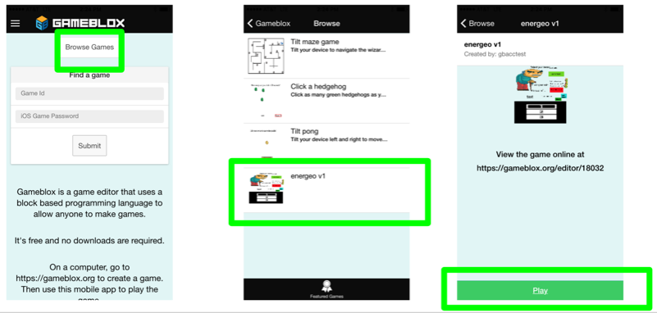

* On the computer in the front of the room, go to: <https://gameblox.org/play/18104>

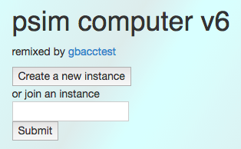

* Click the “Create a new instance” button
* Select “admin” and click submit

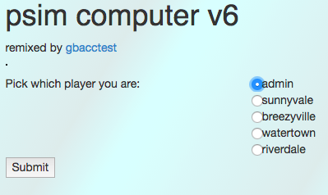

* The screen that is projected should now look like this:

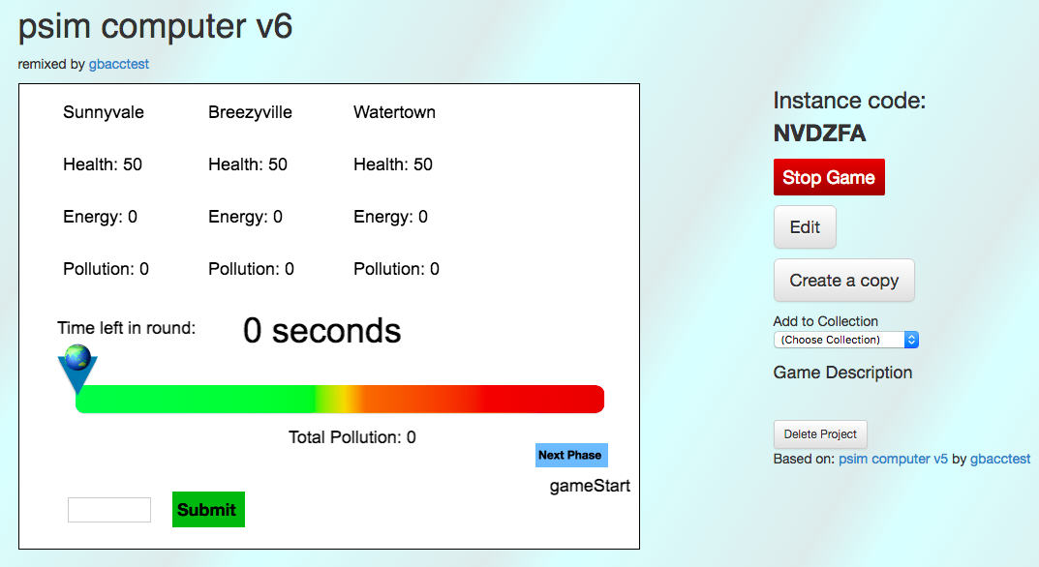

* On all of the other computers, go to <https://gameblox.org/play/18070/>

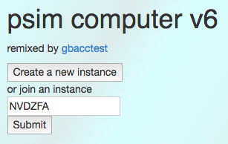

* Type in the instance code in the text box and click submit.
* Choose the team (Sunnyvale, Breezyville, Watertown, Riverdale) and click submit

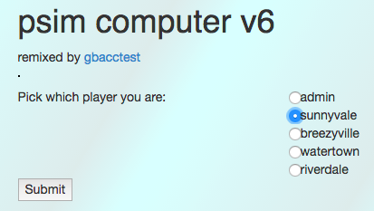

* The resulting page should look like this:

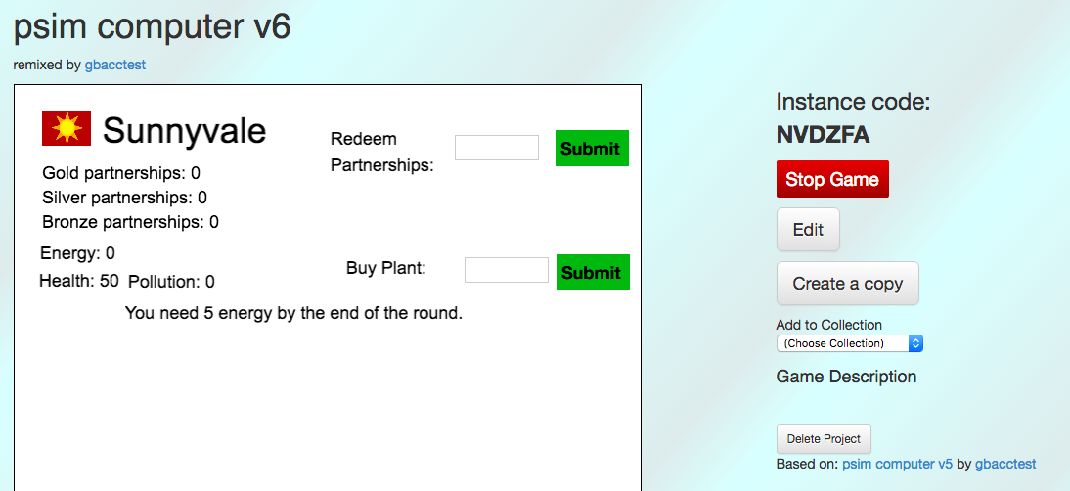

*Partnership Round 1*

* Click the “Next Phase” button on the Admin screen. This will set a timer for 4 minutes. Announce the start of play.
* Players must form partnerships. To do so, they proceed around the room to scan QR codes on each other’s phones.
  + The first time two players scan each others’ QR codes, they both receive a Bronze Partnership.
  + These players may strengthen their partnership to a Silver Partnership by waiting 30 seconds, then scanning each others’ QR codes a second time. If they wait more than another 30 seconds, the partnership times out and they are stuck with the Bronze partnership. They may start the process over if they want to build a stronger partnership with the same partners.
  + Players may similarly strengthen a Silver Partnership to a Gold Partnership by waiting 30 seconds after forming the Silver Partnership, then scanning each others’ QR codes again before another 30 seconds elapse
* Give the players a warning when there is 30 seconds left in the round.

*Energy Round 1*

* Each user will have a code on their phone that they will need to enter on their team computer to redeem their partnerships.
* Once all players on a delegation have redeemed their partnerships, they should decide which power plants to buy. See the Power Plant Cost and Output table in the Delegation Dossier. To buy a plant, players enter the number in the “#” column of the Power Plant Cost and Output Table.
* After buying plants, the delegation decides which plants to use. They must generate a minimum amount of energy each turn or their health will suffer. However, they do not have to use all the plants. Each plant that is used will generate the amount of energy and pollution indicated on the Power Plant Cost and Output Table.
* The collective impact of their energy choices, including pollution and adverse events, are shown on the World Status screen

Repeat

* To play a full game, play 3 sets of Partnership and Energy rounds.

**Energeo Session Walkthrough**

*Full instructions for how to run a live Energeo session with a group of students. Includes agenda, links to introductory slides, and discussion questions.*

A typical Energeo session will last 2.5 hours total. Players will be divided into four delegation teams, and will alternate between meeting in one as a group, and splitting off into four individual rooms. Each team will be assigned their own facilitator, who will follow them to their individual rooms.

The agenda times and discussion questions here are suggestions and may be changed at the Energeo Facilitators’ discretion.

*Introduction (25 Minutes)*

*Location: Main Room*

* Eric will present an introductory slide show about Energeo and its learning goals.
  + [Link to Slides](https://www.dropbox.com/s/vvtdb1z7t0drak0/EnergeoIntro%203-09.key?dl=0)
* There will be four instances of the game running.
  + Each instance has their own facilitator, and will meet in their own room.
  + Each instance has four delegations (Breezyville, Riverdale, Watertown, Sunnydale).
  + Each delegation has 6-7 members, each of whom represent a Ministry (Environment, Foreign Policy, The Interior, etc.)
* Divide the full group into its four instances. Each instance should go to their own room at this time.

*First Play Session (45 Minutes)*

*Location: Individual rooms*

Reminder: we expect that the first play session will end in the players suffering negative consequences from pollution, as they are still learning about the systems involved.

* [Here are the slides that will walk you through the process of showing the players how to play!](https://docs.google.com/presentation/d/1AWso1AcuYbCk734nAxwh78q1DEPCb4znShmmP8GJ_d8/edit?usp=sharing)
* Break up student group into four teams and distribute mobile devices to players.
* Give each team one of four delegation names (Breezyville, Riverdale, Watertown, Sunnydale).
* Give each country their delegation dossier, and instruct players to put on their name tags identifying their delegation.
* Follow the Energeo Instruction Slides, which will have the students start playing the game
* As you play the first round, identify any technical issues and address any questions on how to play.
* Try to keep moving from team to team and player to player. If a player seems lost or is having a technical issue, offer to help. Otherwise, listen in to the conversations they’re having and file away any observations about their strategy (or lack thereof) for discussion after game.

*Debrief/Discussion (15 Minutes)*

*Location: Individual rooms*

* Summarize the outcomes for each country and the impact of the pollution/CO2 levels on all countries.
* Each team’s facilitator takes their team to a separate room for team only discussion. Discussion Questions:
  + How easy was it to meet your county’s energy goals?
  + When you were making decisions about what kind of plants to build, what factors did you consider?
    - Explain what types of energy your country is best at creating.
    - Did the kinds of plants you wanted to build affect your partnerships?
    - Did your goals or strategy change over time?
  + Explain how the amount of pollution you created when creating energy affected your decisions.
  + How much impact did the pollution-related events have on your personal decisions? On your delegation team’s decisions?
* Team Facilitators reconvene the teams in one room. They ask one person from each team to summarize how successful their energy policies were and the impact of the pollution.
  + Summarize how some of the game elements relate to real world situations.
    - In the game, if enough people use fossil fuels, they drive up the pollution meter. If this pollution score reaches 400, this leads to more severe negative climate events. This is analogous to how in the real world, fossil fuel is driving the CO2 levels in our atmosphere above 400 ppm, which is considered the “safe” threshold for our climate.
    - Each delegation gets benefits in producing certain forms of energy due to their climate or natural resources. Thus, it may be easier for some countries, both in the game or the real world, to switch to certain forms of greener energy.
      * Sunnyvale gets 1 more energy per use for a solar plant
      * Breezyville gets 1 more energy per use for a wind plant
      * Watertown and Riverdale both get 1 more energy per use for a hydropower plant.
  + Where did this pollution come from (in the game)?
  + What impact does the pollution have inside and outside the country where it is created?
  + Were you thinking about whether other countries were considering pollution in their energy policies?
  + How is the game’s pollution problem similar to pollution problems in real life?
    - If the students do not pick up on this themselves, point out that the pollution in the game is largely CO2 created from burning fossil fuels. As in real life, there is a tipping point when the CO2 levels reach 400 parts per million where serious adverse events become much more likely.
  + What might you do differently next time you play?
    - Clarify that the players will be playing the same game, with the goal of getting better outcomes.
  + How do international partnerships and relations differ between the game and the real world?
    - Emphasize that climate issues and energy needs are not things any given country or group of people can do on their own.
  + How can you work with other countries to address the pollution problem while still meeting your country’s needs?
    - Try to clearly recap one thing each team is going to do to address the common pollution problem before moving on to the next session.

*Break (15 Minutes)*

*Second Play Session (30 Minutes)*

*Location: Individual rooms*

* (Follow rules in How to Play Energeo, Above)
* Try to keep moving from team to team and player to player. If a player seems lost or is having a technical issue, offer to help. Otherwise, listen in to the conversations they’re having and file away any observations about their strategy (or lack thereof) for discussion after game.
* Consider allowing teams to make suggestions - on possible trades, limitations on how much they should be allowed to pollute - in discussion sessions in between rounds. Be prepared to arbitrate discussion about fairness, differing needs or abilities in terms of energy production, or other points of contention.

*Debrief/Discussion (25 Minutes)*

*Location: Main room*

* Summarize the outcomes for each country and the impact of the pollution/CO2 levels on all countries. Discuss out the outcomes were different from the previous play session.
* Eric reviews concept of the Tragedy of the Commons.
* No team breakouts this time. Group discussion questions:
  + How did the second play session differ from the first?
  + What did you do differently this turn?
  + Did you try to avoid creating as much pollution this turn?
  + Did that make it easier or harder to meet your goals?
  + Did you feel other countries were doing their part to avoid having the pollution levels too high?
  + Were you tempted to allow your country to pollute more in hopes that other countries would pick up the slack?
  + Now that you’ve seen these systems and pressures in effect in a game setting, what might be some important policy changes to make in the real world to prevent the tragedy of the commons and encourage more sustainable energy development? What outcomes do we want to see? How can we incentivize those outcomes? Some examples, if players need a nudge:
    - Climate policy accords between nations.
    - Resource sharing, especially sharing clean/sustainable technology with nations that have less energy development.
    - Funding clean energy research & development.